**CREATING IBM CLOUD SERVICE**

Team Id : PNT2022TMID31048

Project Title : Personal Assistance For Seniors Who Are Self-Reliant

**STEP 1: ENTER YOUR IBM CLOUD LOGIN ID**

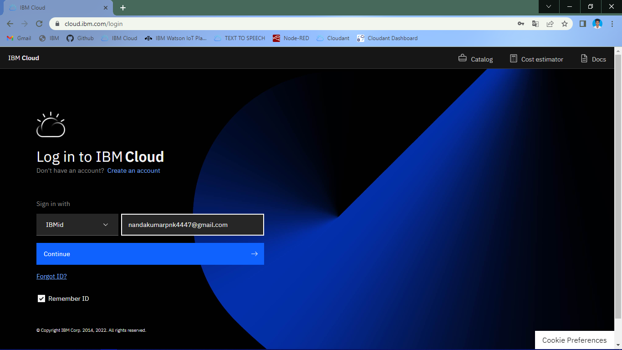

**STEP 2: ENTER YOUR PASSWORD CORRECTLY**

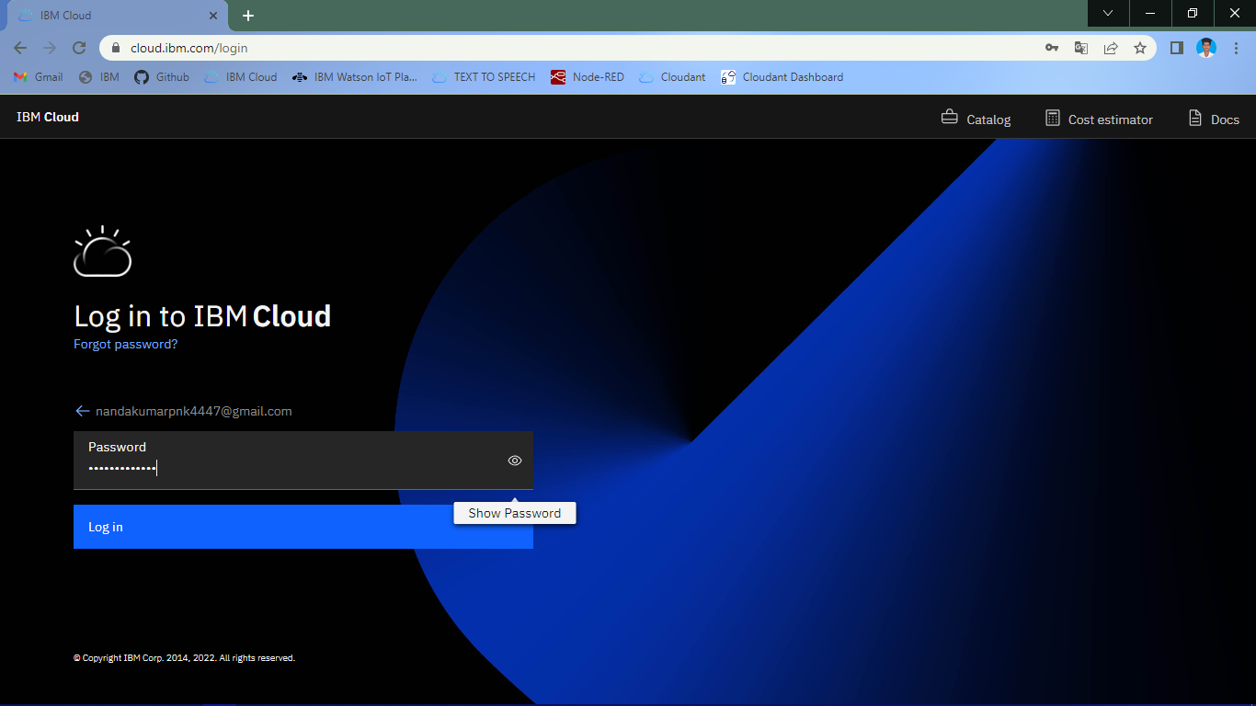

**STEP 3: SELECT IBM CLOUD DASHBOARD**

